Sri Lanka Institute of Information Technology



Lab Submission

<Lab sheet 08>

**<IT24101458>**

**<Sanvidu M.G.M.>**

**Probability and Statistics| IT2120**

B.Sc. (Hons) in Information Technology

Exercise

1. Calculate the population mean and population standard deviation of the laptop bag weights.

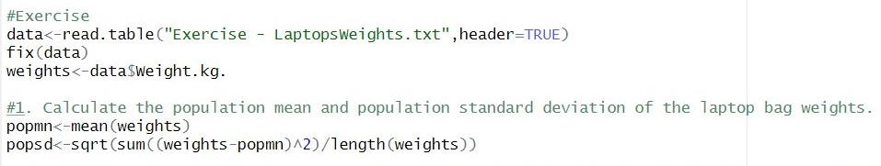

1. 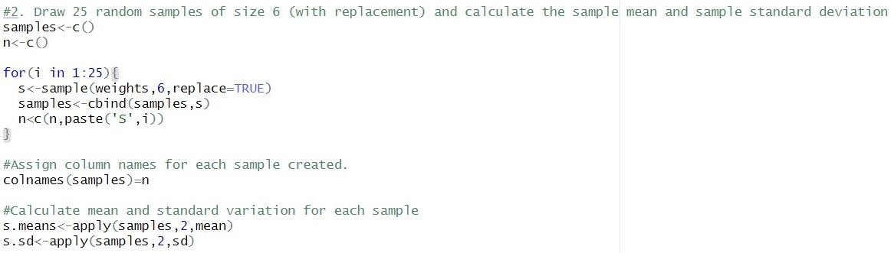Draw 25 random samples of size 6 (with replacement) and calculate the sample mean and sample standard deviation for each sample.

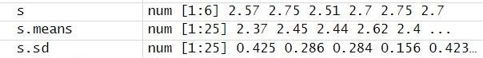

1. Calculate the mean and standard deviation of the 25 sample means and state the relationship of them with true mean and true standard deviation.

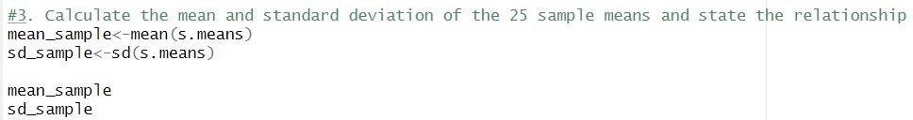

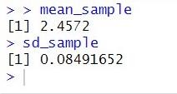

The mean of the 25 sample means is approximately equal to the population mean and the standard deviation of the 25 sample means is approximately equal to the population standard deviation divided by the square root of the sample size.